Docker Project

This docker project is having a wordpress blog with mysql database and these both operating systems are running on docker containers.

We’ll be using Redhat Operating System as the base Operating System.

We’ll be having the storage as Persistent/Permanent Storage, i.e. on crashing of the operating system too our data will be fully saved.

Further, we can launch our data within seconds on another operating system.

Step 1: Firstly we’d to download the respective images from docker hub.

->docker pull wordpress(5.11-php7.3-apaache)

->docker pull mysql(5.7)

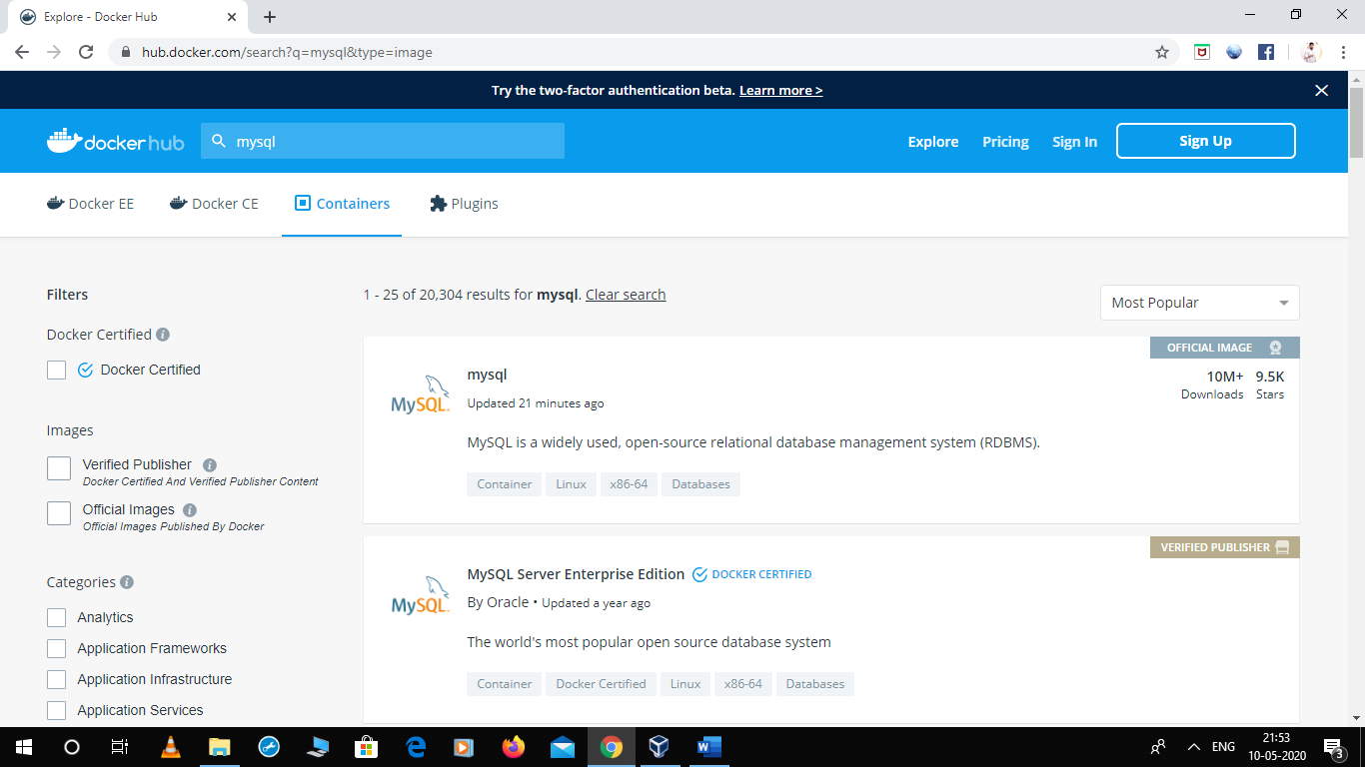

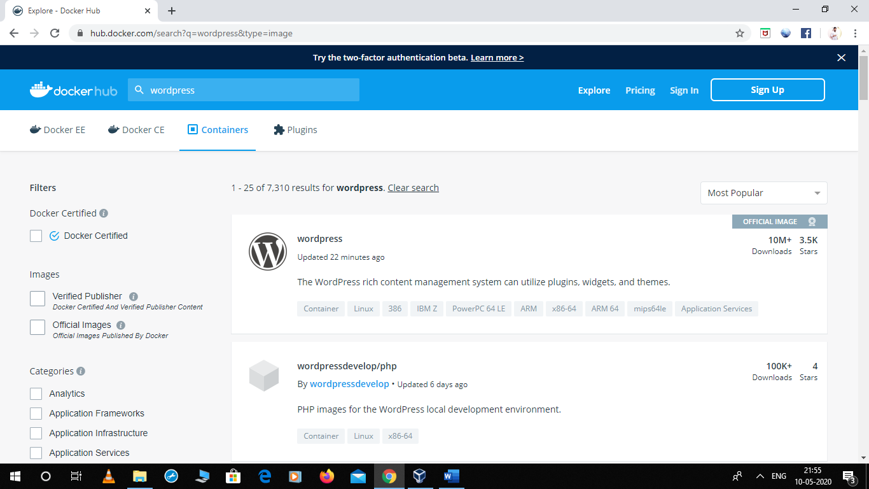

After Downloading these images from docker hub we’d to install mysql too by the command

* Yum install mysql

Step 2: After downloading we can either run them one by one through command line by running the following commands:

* Docker run -dit -e MYSQL_ROOT_PASSWORD=*** -e MYSQL_USER=*** -e MYSQL_PASSWORD=*** -e MYSQL_DATABASE=*** -v mysql_storage:/var/lib/mysql –NAME mydb mysql:5.7
* DOCKER RUN -DIT -e WORDPRESS_DB_HOST=dbos -e WORDPRESS_DB_USER=*** -e WORDPRESS_DB_PASSWORD=*** -e WORDPRESS_DB_NAME=*** -v wp_storage:/var/www/html –name wpos –link dbos -p 8081:80 php7.3-apache

STEP 3: We can use the above defined steps or we can use the “Docker Compose”, i.e. to write a code for all the above process which we did above.

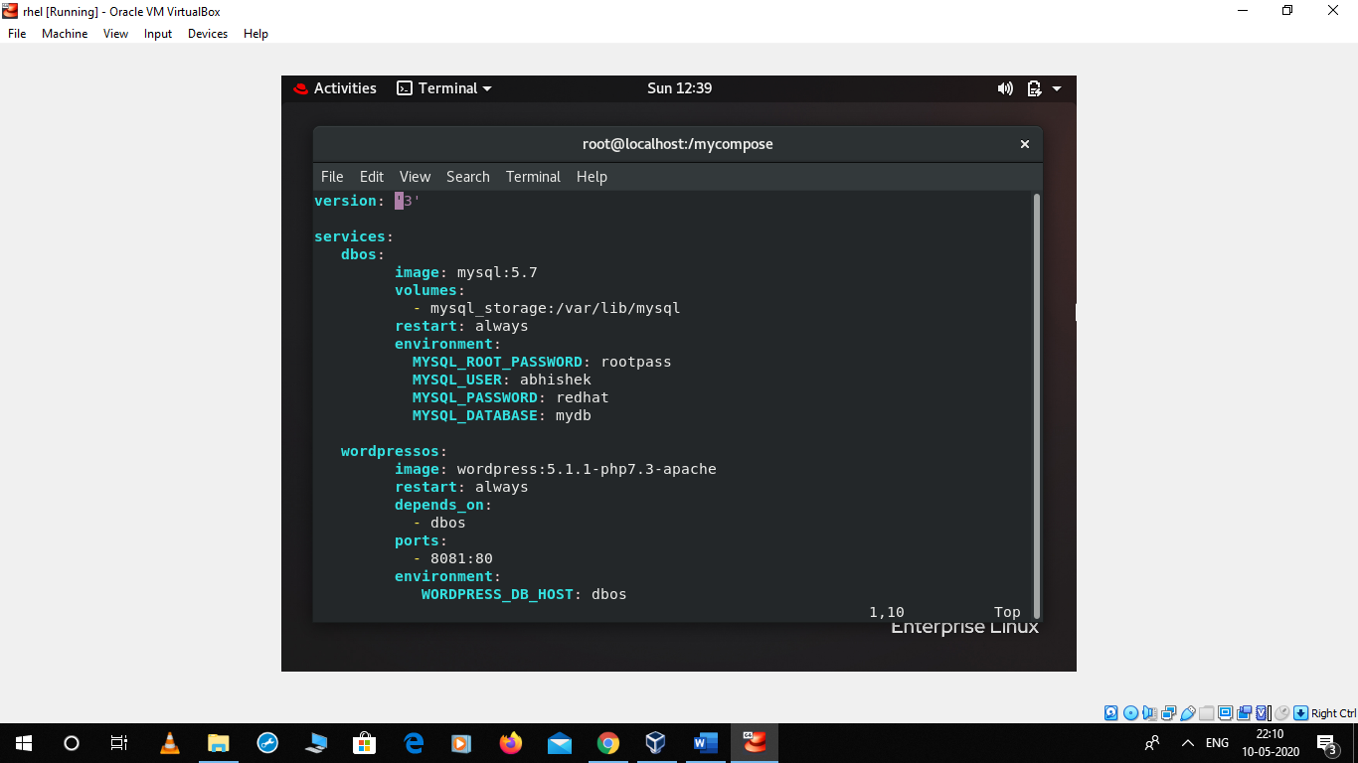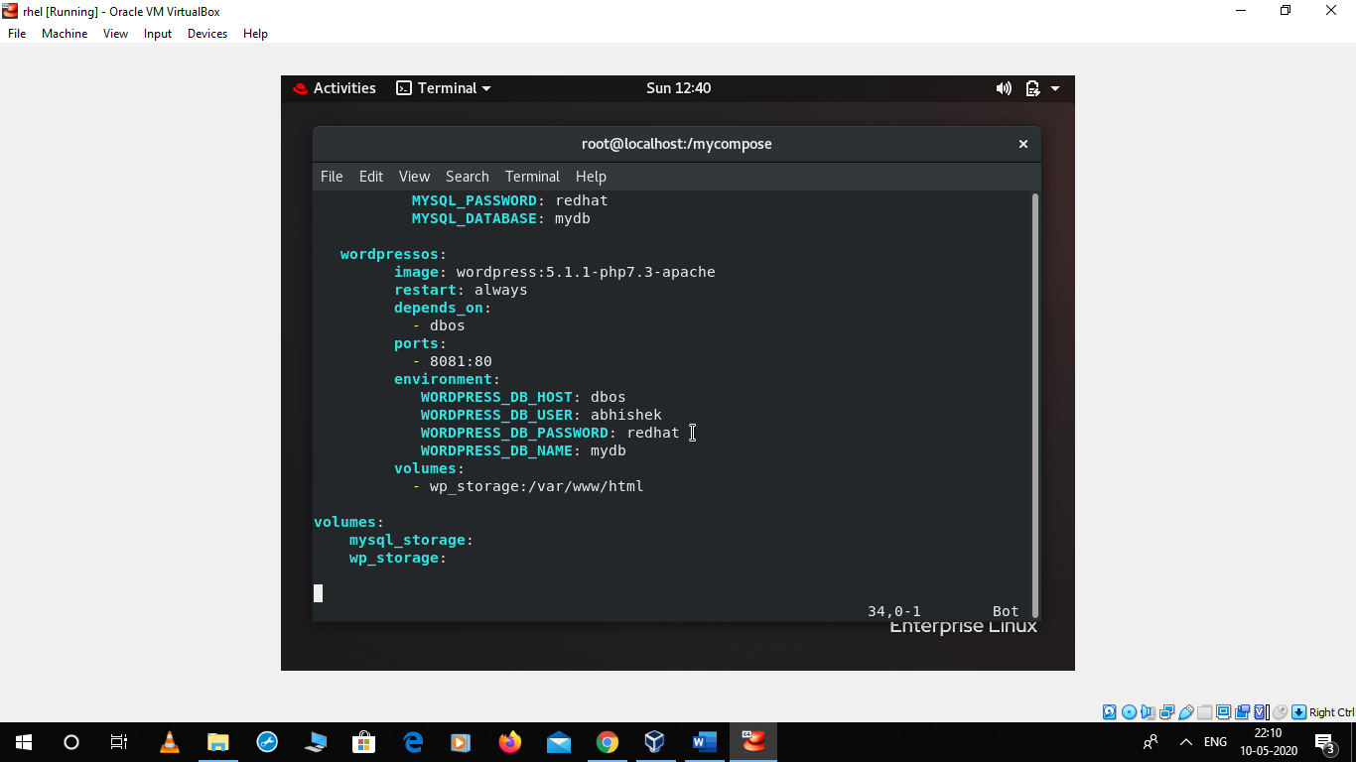

Hence, we just automated this process of the above code, i.e. we just put the above lines which we were running on command line into a “.yaml” file through docker compose.

Here are the pics of the website which is being launched by the further commands:

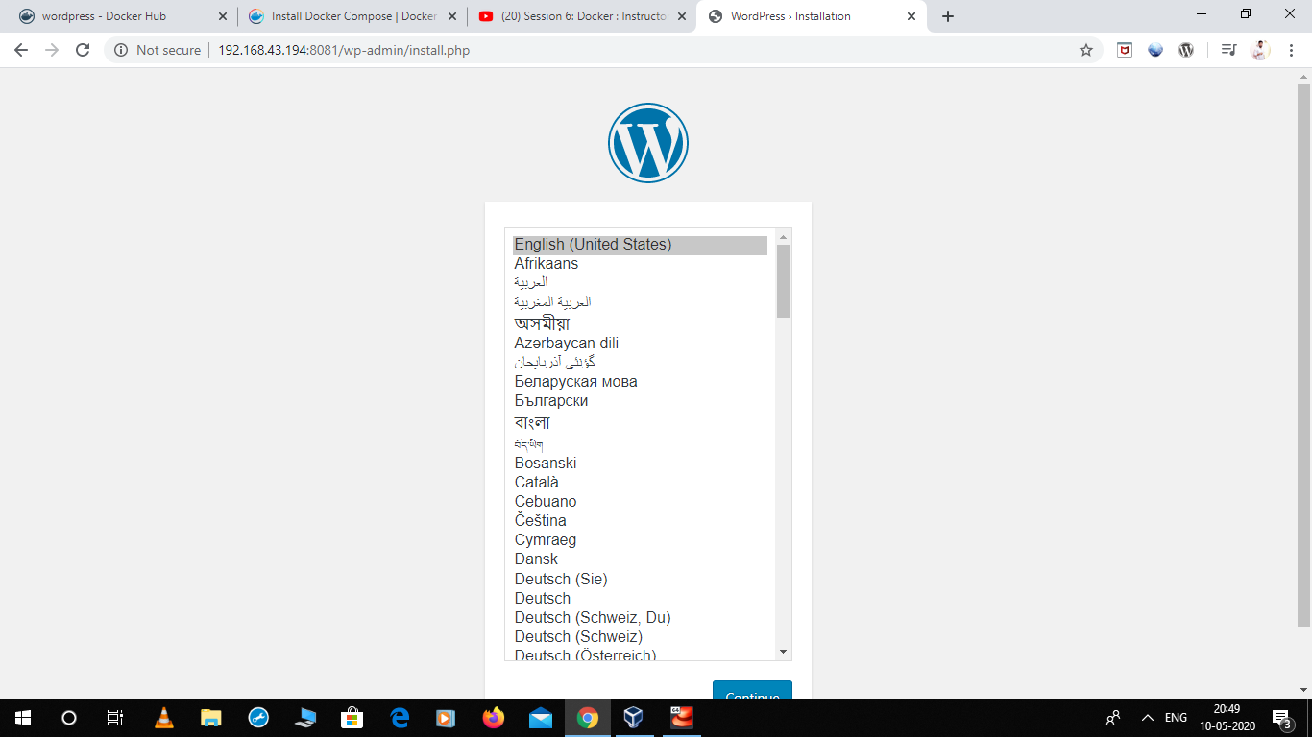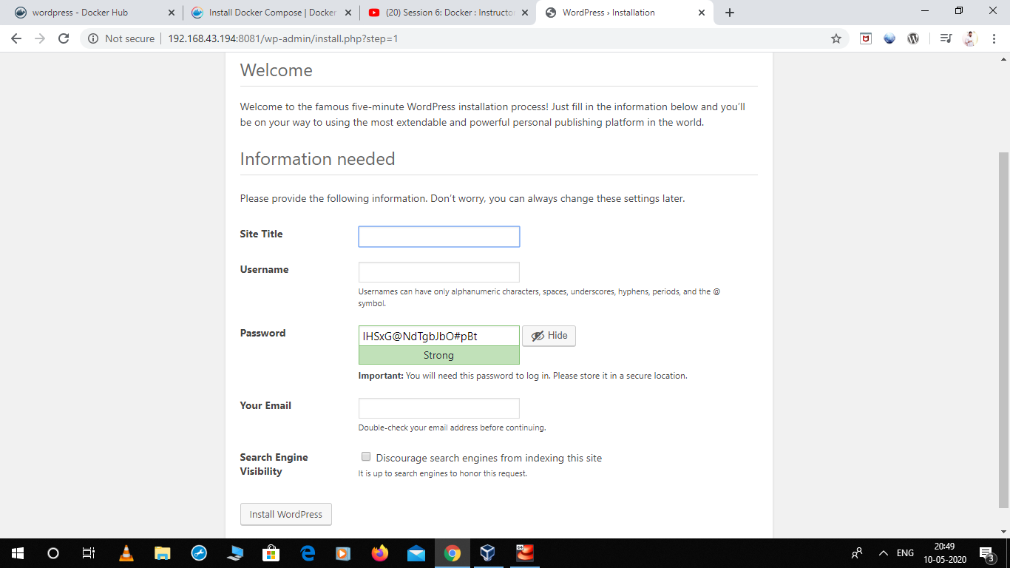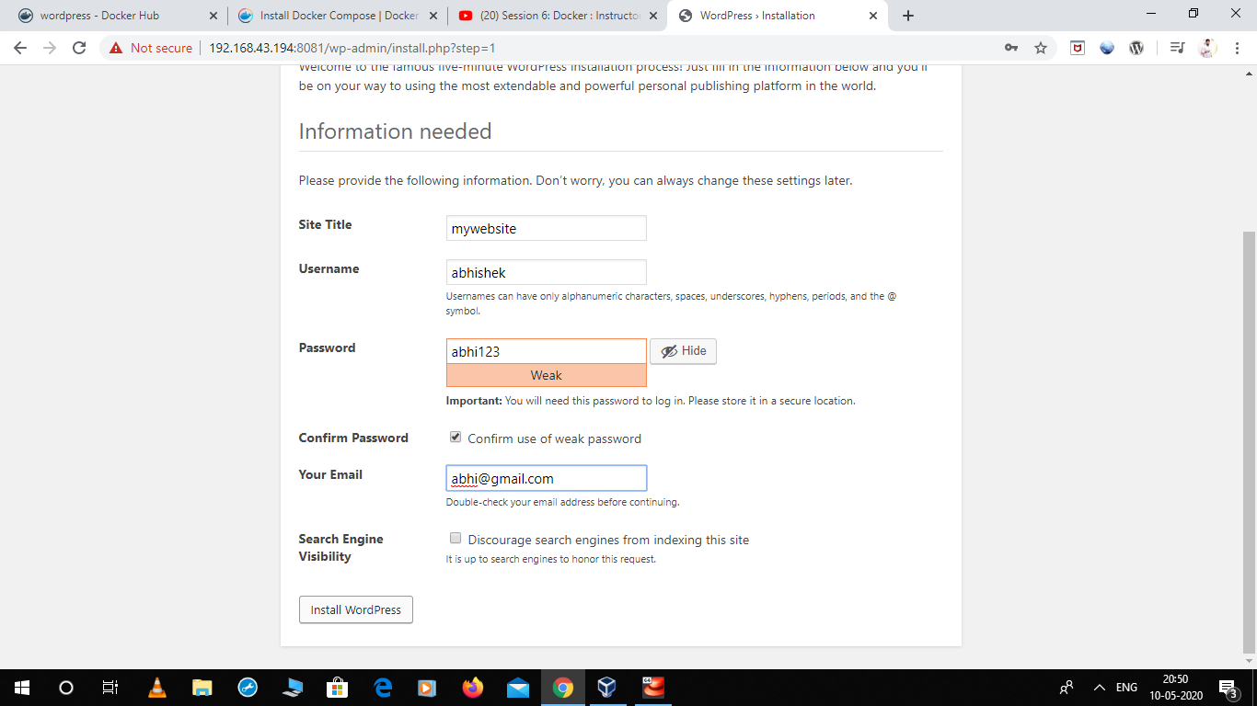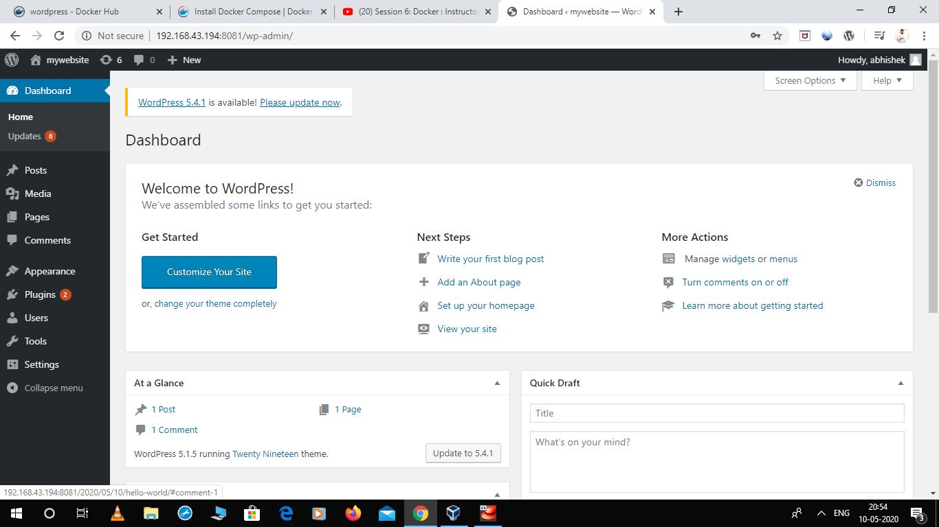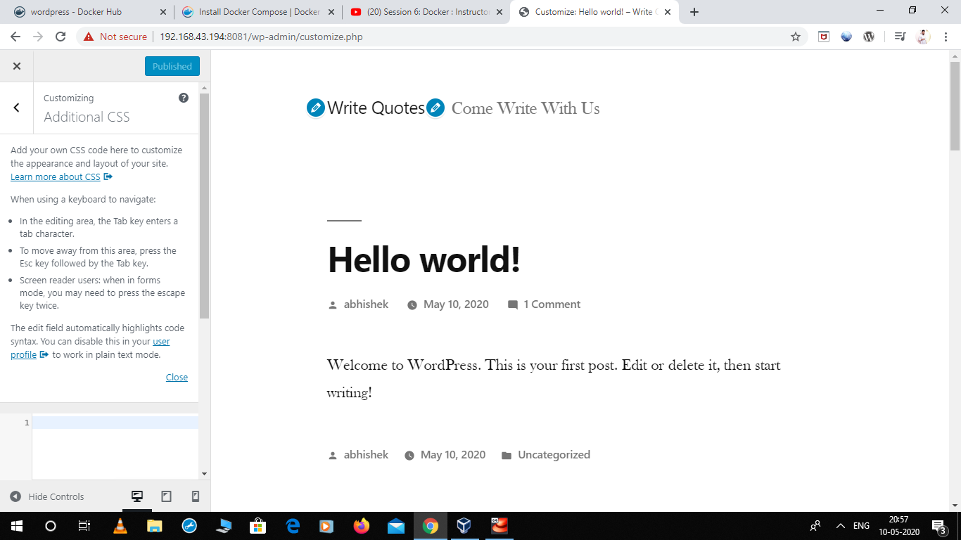

This is our fully fleshed website working on two different operating systems which are running on a base operating system through docker.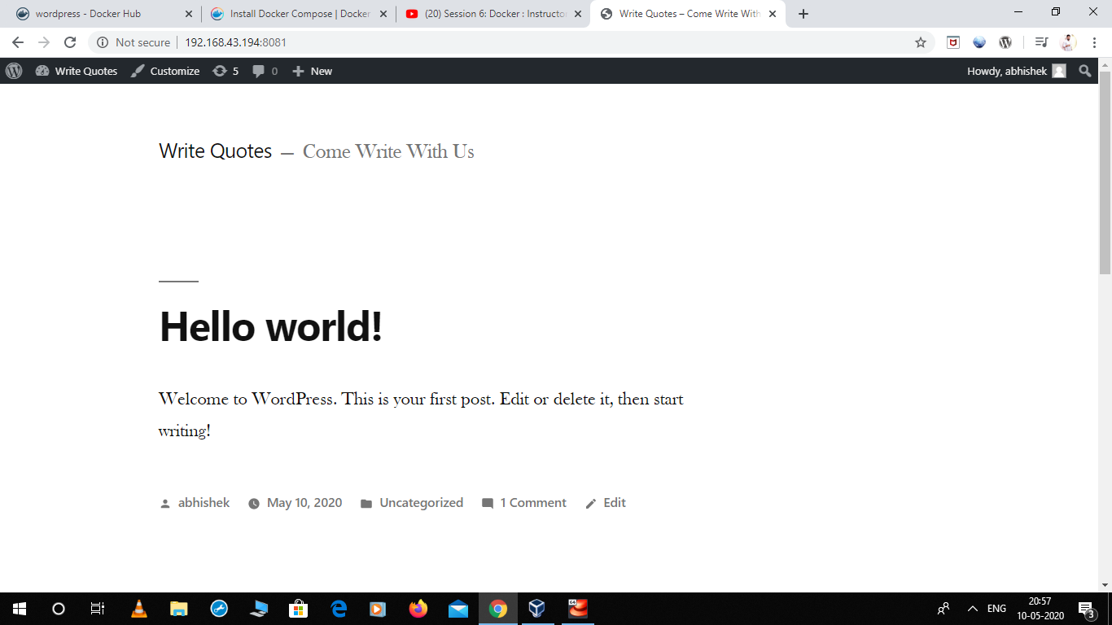

Further Automation:

Further using Jenkins we can automate the process of launching the webserver operating system on being crashed by creating a job in Jenkins.